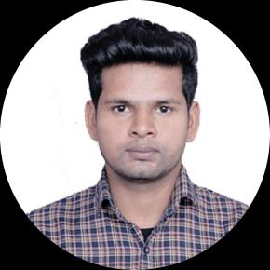

***Address:***

*New Delhi, India-110025*

***Phone:***

*+91 9955382726*

***Email:***

*ahmadrafi025@gmail.com*

***GitHub Profile:***

*https://github.com/iamrafee01*

***LinkedIn Profile:***

*https://www.linkedin.com/in/iamrafee01*

* JEE - Main 2019 Qualified
* Training in Java Expert
* Training in C++ & Data Structure
* Training in Web Development
* **Java (3 star) --** HackerRank
* **Internship** -- C++ & Data Structure
* **Internship** -- Engineering Intern (EV - TCA)

**Achievement / Certifications**

English– Professional

Hindi – Native

**Languages**

**B.TECH - EEE, Grade :- 8.33,** 2019 to Present..

Maharaja Surajmal Institute Of Technology, New Delhi, India

**Qualification**

**1. Engineering Intern** – 05/2022 to 07/2022

Vardhan Consulting Engineers. WFH **(Internship)**

**2. C++ & Data Structure** – 04/2022 to 05/2022

**Internship Studio**. WFH **(Internship)**

**Internship / Training**

* Team player
* Adaptability
* Leadership
* Conceptual skills
* Time management
* Java Programming
* Web Development
* Minor in C++
* Critical Thinking
* Analytical skills
* Problem solving

**Skill Highlights**

I want to be counted amongst the best professionals in my field and also hope to be a part of an enthusiastic team ready to take challenges .

**RAFI AHMAD**

MSIT - Delhi

**Summary**